Vanity Number Service Contact Center Design Specifications

Contents
Background 3
Component Inventory 4
Architecture Overview 5
Design Diagram 6
Vanity Main Menu Diagram 6
Vanity Customer Queue Diagram 7
Contact Flows 8
VanityService_Main 8
VanityNumber_CustomerQueueFlow 9
Lambda Functions 9
VanityNumberGen3 9
DynamoDB Table 11
NumberVanityMapping 11
Dictionary_Vanity 11
VanityNumbers 12
Design Solution / Implementation 12
Solution Overview 12
Why I implemented the solution this way 12
DynamoDB for Keypad Mapping 12
DynamoDB for Dictionary Words 12
Helper Structure 13
Scoring & Ranking Strategy 13
Struggles and Problems I Overcame 13
AWS Account and Amazon Connect Challenges 13
Performance Optimization 14
Formatting Vanity Numbers 14
Shortcut taken (Production Bad Practices) 14
Using ScanCommand to Read DynamoDB Tables 14
Simple Fallback Results 14
In Memory Lambda Caching 14
Improvements with More Time 15

Background
In the highly competitive landscape of modern customer service, a brand’s accessibility directly influences customer acquisition and retention. Enterprise contact centers are increasingly prioritizing immediate, low-friction entry points to connect consumers with support and sales ecosystems. Among these strategies, toll-free vanity numbers—alphanumeric phone numbers that map directly to brand identities or specific services (e.g., 1-800-468-FREE or 1-800-MEDIA)—remain a critical channel for driving inbound call volumes, reinforcing brand recall, and maximizing marketing ROI across broadcast and digital media.
While vanity numbers are effective marketing tools, implementing them dynamically within an enterprise cloud contact center introduces significant engineering challenges. Traditional Interactive Voice Response (IVR) systems often rely on static routing paths or rigid databases, making it difficult to scale or adapt to changing customer needs.
This design specification details the development of an intelligent, automated, and serverless Vanity Number Service seamlessly integrated within an Amazon Connect telephony infrastructure.
The core objective of this architecture is to instantly intercept inbound telephone calls, parse the digits in real-time, cross-reference them with dynamic dictionaries, and compute optimal, context-aware alphanumeric strings. By leveraging a decoupled, event-driven design featuring AWS Lambda for compute logic and Amazon DynamoDB for scalable storage, this service delivers high performance and low latency. It is built to process thousands of concurrent interactions while keeping database lookups fast, cost-effective, and safe from system time-outs.

Component Inventory
The purpose of this section is to itemize all applicable components and their corresponding types that the Vanity Number Service Contact Center is comprised of.

Component | Type
VanityService_Main | Contact Flow
VanityNumber_CustomerQueueFlow | Customer Queue Flow
VanityNumberGen3 | Lambda
NumberVanityMapping | DynamoDB
Dictionary_Vanity | DynamoDB
vanityNumbers | DynamoDB
BasicQueue | Queue
Table 1. Vanity Number Service Component Inventory

Architecture Overview
The purpose of this section is to overview the design of Vanity Number Service Contact Center
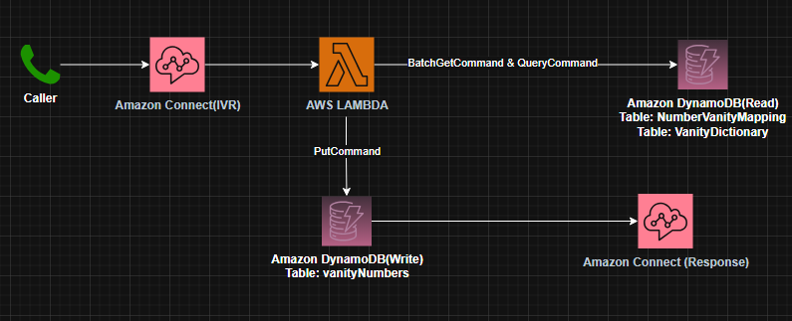
Figure 1 Architecture Diagram
This architecture diagram illustrates a serverless telephone application built on AWS. It uses an event-driven design to dynamically process an incoming call, look up vanity options, log the results, and return them back to the caller in real-time.
When a caller dials in, Amazon Connect triggers an AWS Lambda function that cleans the phone number, fetches keypad and dictionary configurations from DynamoDB read tables (optimized by a 5-minute RAM cache), saves the highest-scoring choices to a DynamoDB write table, and returns a JSON payload so the IVR can instantly announce the vanity options to the customer using Text-to-Speech.

Design Diagram
The purpose of this section is to visualize all Design Diagrams of the Vanity Number Service Contact Center.

Vanity Main Menu Diagram
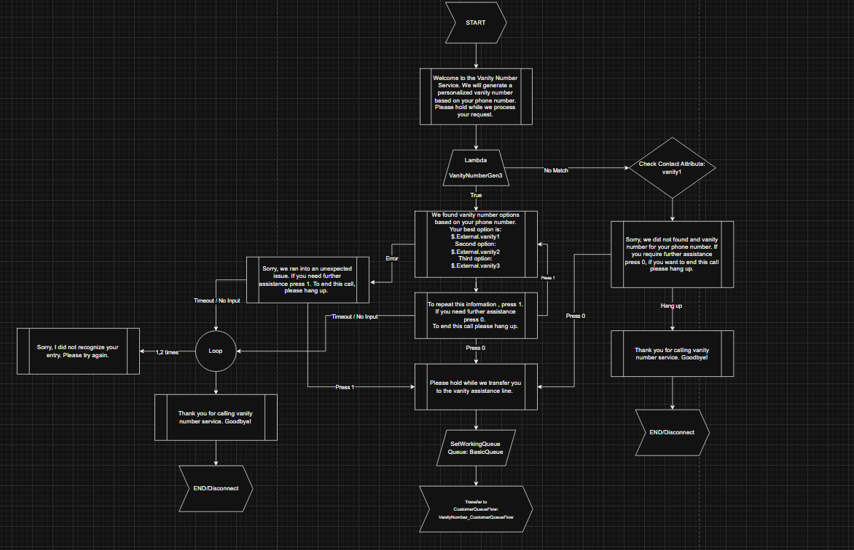
Figure 2 Vanity Number Service Main Menu Diagram

Vanity Customer Queue Diagram
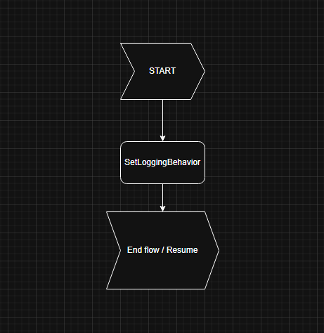
Figure 3 Vanity Number Service Customer Queue Diagram

Contact Flows
The purpose of this section is to visualize all contact flow diagram of the Vanity Number Service Contact Center.

VanityService_Main

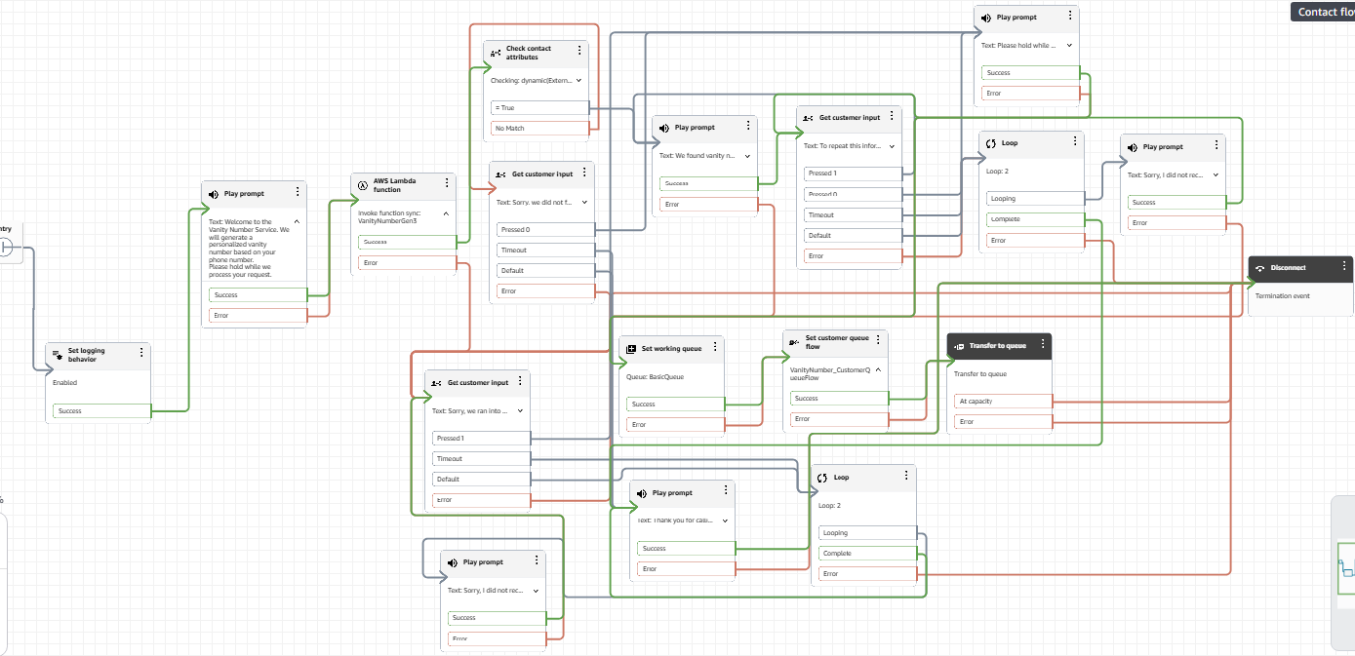
Figure 4 VanityService_Main Contact flow

VanityNumber_CustomerQueueFlow
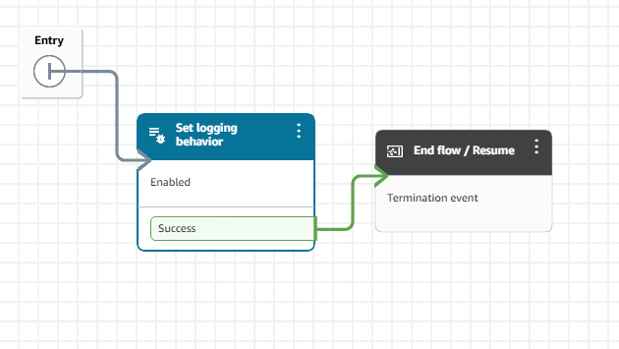
Figure 5 VanityNumber_CustomerQueueFlow contact flow

Lambda Functions

VanityNumberGen3
The VanityNumberGen3 Lambda function acts as the central engine of your application. It wakes up instantly when invoked by Amazon Connect. Inside the Lambda, the code runs to parse the phone number, clean up any formatting characters (like dashes or spaces), and coordinate reading from and writing to your databases. To map numbers to letters, the Lambda function sends a BatchGetCommand & QueryCommand to your read-heavy tables:
- NumberVanityMapping: (Mapped to your DIGIT_MAPPING_TABLE(NumberVanityMapping)) This provides the telephone keypad matrix (e.g., matching the number 2 to A, B, C).
- VanityDictionary: (Mapped to your PREFERRED_WORDS_TABLE(VanityDictionary)) This provides the custom list of target branding terms (like FREE or MEDIA).
- Once the Lambda finishes processing and scores the best alphanumeric choices, it sends a PutCommand to the vanityNumbers table. This save logs of the callerID, timestamp and their calculated top vanity variations.
This is a sample Request for VanityNumberGen3 lambda.
- This request is the data sent to Lambda from the IVR when a customer makes a call.
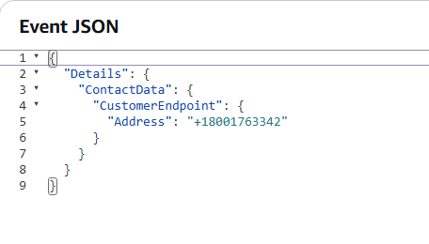
Figure 6 Sample Test Request

This is a sample Response for VanityNumberGen3 lambda.
- The response is the result returned by lambda after processing the request. It shows that a vanity number was successfully generate and provides important details like CallerNumber, the top3 vanity, and the vanityNumbers.

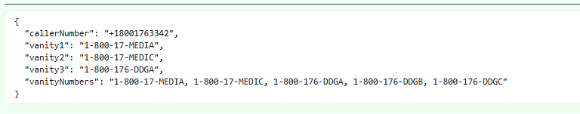
Figure 7 Sample Response

DynamoDB Table

NumberVanityMapping
This table acts as the system’s digital telephone keypad directory. It will tell the code which letters belong to which numeric keys when translating standard number to string (text).
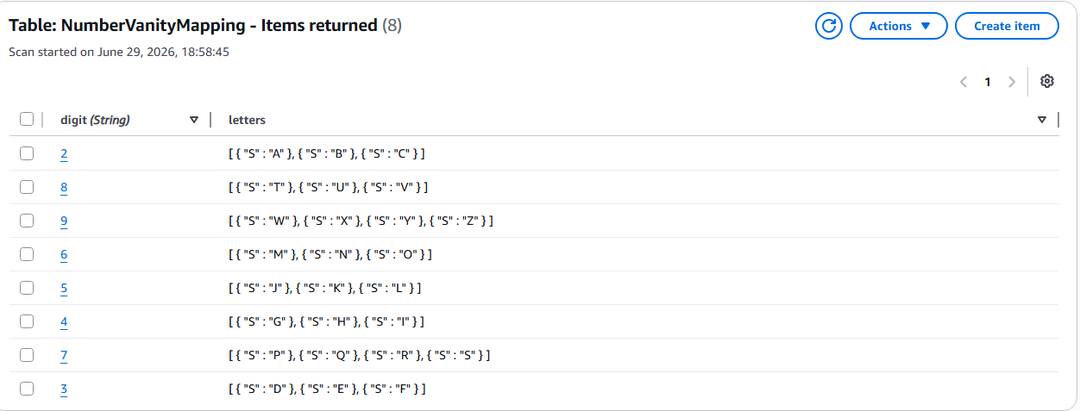
Figure 8 NumberVanityMapping Table

Dictionary_Vanity
This table contains the custom list of marketing words that actively want the system to look for within a phone number (such as FREE, MEDIA, HELP, CARS etc…). Instead of letting the lambda randomly guess combinations, this table tells the system what are the readable words needed for the system.
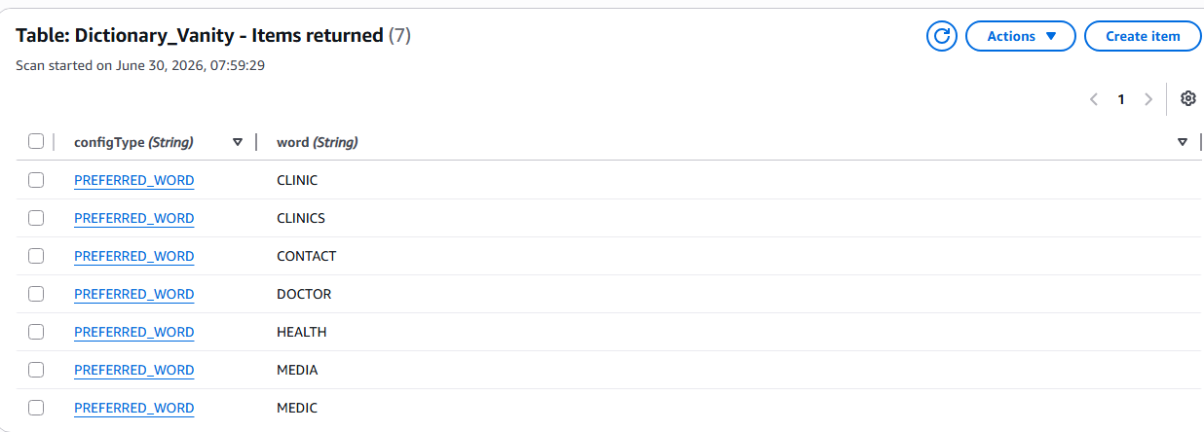
Figure 9 VanityDictionary Table

VanityNumbers
This table acts as the system’s transactional audit log and history registry. Every time a customer completes a call and the lambda function finishes its calculations it will save the result here in this table.
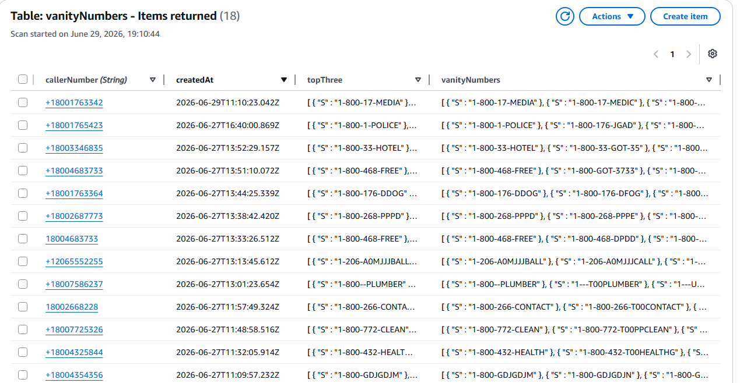
Figure 10 VanityResults Table

Design Solution / Implementation

Solution Overview
The solution consists of 3 AWS Services these are AWS Lambda function integrated with Amazon Connect and Amazon DynamoDB. When a caller contacts Amazon Connect, the contact flow invokes the lambda function and passes the caller’s phone number as a payload attribute. The lambda function normalizes the input, generates possible vanity numbers, stores the top results in DynamoDB, and returns the top suggestions back to Amazon Connect to be announced to the caller via Text-To-Speech (TTS).
To keep it maintainable and aligned with architecture principles, the lambda is divided into helpers. Each helpers are responsible for a single task, such as loading configuration data, retrieving dictionary words, converting words to digits, generating vanity matches and saving results.

Why I implemented the solution this way

DynamoDB for Keypad Mapping
Instead of hardcoding the static T9 Keypad mapping directly inside the lambda function. Although the mapping are rarely changes, storing it in DynamoDB externally demonstrates a configuration driven design where application logic is separated from configuration data.

DynamoDB for Dictionary Words
The dictionary of possible vanity words is also stored in DynamoDB. This allows new words to be added or removed without modifying or redeploying the Lambda function. In a production environment, the dictionary could be managed by an administrative interface or updated through automated processes.

Helper Structure
- phoneHelper.js: normalizes the incoming phone number.
- configHelper.js: it looks up the keypad mappings and word list. It also managed the 5 minute RAM cache so that the system will not waste time making repeated trips to DynamoDB.
- vanityHelper.js: contains the primary logic. It takes the clean numbers, run the scoring system (weighting longer words and end-of-number alignments higher), and outputs the top 5 vanity recommendations.
- dynamodbHelper.js: handles the actual database commands (BatchGetCommand & QueryCommand to read configurations and PutCommand to log or save the results).

Scoring & Ranking Strategy
- Length Weighting (Longer = Better)
- Awards points based on word length. The longer the real word, the higher the score
- A long, unified word is much easier for a human to remember than multiple short, fragmented pieces.
- Example: 1-800-CLINICS will easily outscore 1-800-CLINIC-7
- Completeness (Real Words vs. Letter Fragments)
- Full, valid dictionary words are given a major point boost compared to random letter combinations or clipped word pieces.
- Callers remember actual words. Randomly generated strings of letters look like "alphabet soup" and confuse customers.
- Example: 1-800-468-HELP will score much higher than 1-800-468-GJKP
- Positions(The Power of Suffix)
- If a dictionary word lines up perfectly at the very end of the phone number, the engine awards a significant score bonus.
- Consumers are trained by decades of advertising to expect vanity words at the tail end of a commercial phone number.
- Example: 1-800-411-CARS (Anchored perfectly at the end) scores much higher than 1-800-CARS-411 (Hidden in the middle).

Struggles and Problems I Overcame

AWS Account and Amazon Connect Challenges
One of the first challenges I encountered was setting up the required AWS services. Initially, I created an AWS account using the Free Tier plan. However, I soon discovered that Amazon Connect is not fully accessible under the Free Tier, which prevented me from completing the assignment. To continue with the project, I upgraded my AWS account to a paid plan. After gaining access to Amazon Connect, I encountered another issue. Although my AWS account was brand new and I had never claimed a phone number before, I was unable to claim an Amazon Connect phone number. I contacted AWS Support regarding the issue, and they informed me that it had been reported internally for investigation. Unfortunately, I have not yet received a resolution. Because of this limitation, I was unable to perform end-to-end testing using Amazon Connect. Instead, I validated the Lambda function and its logic by creating and using Lambda test events that simulated the payload Amazon Connect would send. This allowed me to verify the vanity number generation, DynamoDB integration, and Lambda response format, although the complete integration with Amazon Connect could not be tested due to the unresolved AWS account issue.

Performance Optimization
One of the main technical challenges was avoiding the exponential number of letter combinations that can be generated from a phone number. A brute-force approach would generate thousands (or even millions) of possible combinations, making it inefficient and potentially causing Lambda execution delays or timeouts.
To solve this, I reversed the matching process. Instead of generating every possible letter combination from the phone number, I converted each dictionary word into its corresponding T9 numeric representation and checked whether that numeric sequence existed within the caller's phone number. This approach significantly reduced the search space and improved performance from an exponential-time search to a simple linear scan of the dictionary.

Formatting Vanity Numbers
Another challenge was preserving the readability of the generated vanity numbers. Since matching words can appear anywhere within the phone number, I implemented a formatting utility that reconstructs the phone number by replacing only the matching digit sequence with the corresponding word while keeping the remaining digits and standard US phone number format intact. This produces vanity numbers that are both readable and familiar to users.

Shortcut taken (Production Bad Practices)

Using ScanCommand to Read DynamoDB Tables
I used ScanCommand to load the keypad mapping and dictionary words because it was the fastest way to develop and test the application. However, this is not recommended for production since scanning an entire table becomes slower and more expensive as the data grows. A better approach would be to use indexed queries, GetItem, BatchGetItem or will search more efficient to use for the system. But I tried now to use BatchGetCommand for the mapping of digits and QueryCommand for the dictionary words which is better especially on costing.

Simple Fallback Results
When the system runs out of real words from your dictionary, the recursive tree fallback algorithm fills the remaining slots with raw, sequential character combinations. While it guarantees you return 5 results, it can result in messy letter combinations (like 1-800-468-GJKP) that are frustrating for a caller to write down and completely useless for corporate branding.

In Memory Lambda Caching
The configuration data, keypad mappings, and dictionary words are cached directly inside the global memory space of the Lambda function container with a 5-minute Time-To-Live (TTL) configuration. In a production environment, if a client updates the dictionary table in DynamoDB (such as adding a new word), that change will not take effect immediately. Example: If I have only CLINIC in my dictionary and the number is related to CLINIC and when I input CLINICS in the dictionary it will take time to effect the CLINICS for that certain scenario.

Improvements with More Time
If I had more time, I would make the following improvements:
- Replace table scans with better queries. Instead of scanning the entire DynamoDB tables, I would redesign the data model to use Query GetItem, BatchGetItem or will search more efficient to use for the system. But in here, since I have extra time to check, I already used QueryCommand and BatchGetItem.
- Expand the dictionary. I would add more words and organize them into categories such as business, healthcare, retail, and customer service to generate more meaningful vanity numbers. I will also search some t9 numbers that have more combination of words.
- Strengthen error handling and validation. I would add more detailed validation, error messages, retries, and structured logging to make the application more reliable.
- Complete end-to-end Amazon Connect testing. Due to an issue with claiming an Amazon Connect phone number on my AWS account, I was only able to test the Lambda using test events. With more time and a resolved AWS issue, I would fully test the contact flow using live phone calls and will debug if any errors came up.
- Will also apply real production naming conventions for Lambda, DynamoDB and Amazon Connect Contact Flows.

